# Task

Database has such structure:

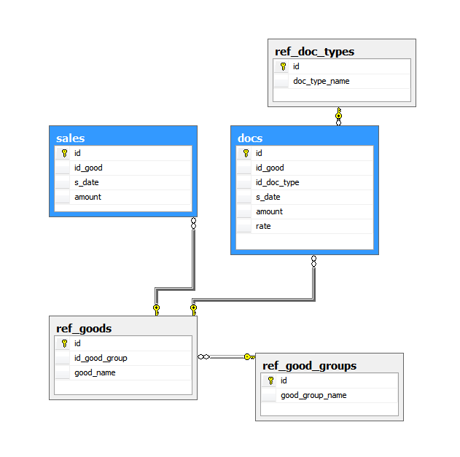

By blue marked tables of facts, by grey – dimension tables.

Script for tables creation and filling is in the attachment.

Task 1.

Write script for selecting of sales sums for the periods:

* YTD – from the beginning of current year until the current date, including it,
* MTD – from the beginning of current month until the current date, including it,
* QTD – from the beginning of current quarter until the current date, including it,
* PYTD – from the beginning of the previous year until the same as today date of previous year,
* PMTD – from the beginning of the same month of previous year until the same as today date of previous year,
* PQTD – from the beginning of the same quarter of previous year until the same as today date of previous year,

Show results ignoring time.

Include into results columns [good_name], YTD, MTD, QTD, PYTD, PMTD, PQTD.

Task 2.

Write script for selection of the docs with such conditions:

* Docs from the Dec 2013,
* Results are grouped by such weeks:
  + 1 week – from 01.12.2013 to 08.12.2013
  + 2 week – from 09.12.2013 to 15.12.2013
  + 3 week – from 16.12.2013 to 22.12.2013
  + 4 week – from 23.12.2013 to 31.12.2013,
* In each week for each good return only the last document for this week. Keep in mind, that in case during the last day there were few documents with one good – return the document with the minimum(rate) and max(s_date).

Include into results columns: WeekNum, doc id, good_name, good_group_name, s_date, amount, rate.

Task 3.

Write script for selecting sum(sales) with such conditions:

* Date begin and date end as parameters,
* Group sum(sales) per [good_name] (which show in rows) and per dates (which are going to the column headers). Keep in mind, that since we can set various begin and end date as parameters for the query – the number of columns in the final report is unknown.